Working with Table Relationships

It is easy to view all the foreign key relationships in which a table is participating. Follow these
steps:

1. Right-click the table and select Modify. The design of the table appears (see Figure 5.9).

Figure 5.9. While the design of the table is visible, you are able to
select the Relationships tool on the toolbar.

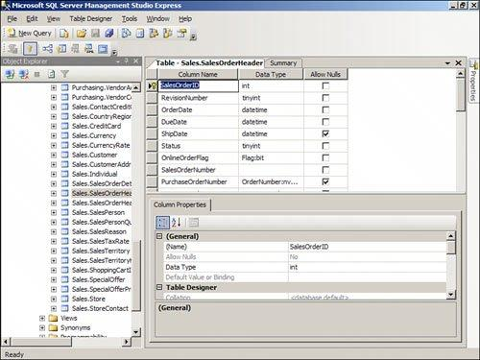

2. Click the Relationships tool on the toolbar. The Foreign Key Relationships dialog appears (see
Figure 5.10).

Figure 5.10. The Foreign Key Relationships dialog enables you to
work with the relationships associated with a table.
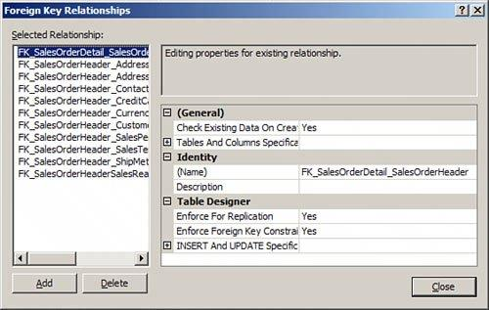

[View full size image]

3. Click a relationship to select it. The properties of that relationship appear.

Adding a Foreign Key Relationship

The Foreign Key Relationships dialog also allows you to add an index. Simply click the Add button.
A new relationship appears with a default name and without a description. Before you take any
further action you should supply the Tables and Columns Specification covered in the section "How
to Designate Table and Column Specifications." You must designate the table and column
specification before SQL Server Express will accept the new relationship.

Deleting a Foreign Key Relationship

Deleting a foreign key relationship is easy. Follow these steps:

1. While in the Foreign Key Relationships dialog, select the relationship you wish to
remove.

2. Click the Delete button. SQL Server Express removes the relationship without warning.

How to Designate Table and Column Specifications

By entering a Tables and Columns specification, you designate the foreign key table that will
participate in the relationship, the field in the foreign key table that will participate in the
relationship, and the field in the current table that will participate in the relationship. To work with
the Tables and Columns Specification, follow these steps:

1. In the Foreign Key Relationships dialog, click to select Tables and Columns Specification.

1. Click the Build button (...) that appears to the right. The Tables and Columns dialog appears
(see Figure 5.11).

Figure 5.11. The Tables and Columns dialog enables you to designate
what tables and fields participate in the relationship.

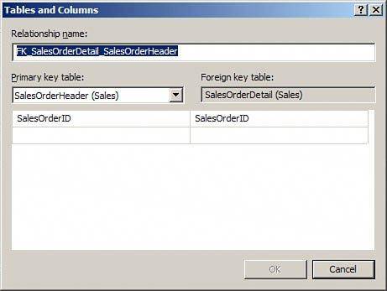

3. If you want to, modify the relationship name. You will generally want to rename the
relationship to more accurately reflect the relationship that you are creating (for example,
FK_Customers_Orders_CustomerID).
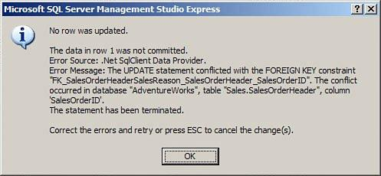

4. Click to select the primary key table that will participate in the relationship. For example, if
you are creating foreign keys for the Orders table, you would designate the Customer table as
the primary key table.

5. Use the drop-down on the left (under the primary key table) to select the field(s) that will
participate in the relationship. For example, in the foreign key relationship between Orders and
Customers, the CustomerID in the Customers table participates in the relationship.

6. Use the drop-down on the right (under the foreign key table) to select the field(s) in the
current table that will participate in the relationship. The complete dialog appears in Figure
5.12. In the relationship between the Orders table and the Customers table, the foreign key
field participating in the relationship would be the CustomerID field.

Figure 5.12. The Completed Tables and Columns dialog, showing the
relationship between the Customers table and the Orders table.

7. Click OK to complete the process. SQL Server Express returns you to the Foreign Key
Relationships dialog.

How to Add a Relationship Name and Description

It is helpful to provide a descriptive name for each relationship that you add, and for you to provide
a brief description of each relationship. This way when you are viewing a relationship in the Foreign
Key Relationships window you can easily see the nature of the relationship that you have selected.

To enter or change a name for the relationship simple click the (Name) property for the
relationship. Enter or change the name as you desire.

To enter a description for the relationship, click the Description property for the index. Enter a short
description of your choice.

How to Determine when Foreign Key Relationships
Constrain the Data Entered in a Column

As you can see, establishing a relationship is quite easy. Establishing the right kind of relationship
is a little more difficult. When you attempt to establish a relationship between two tables, SQL
Server makes some decisions based on a few predefined factors:

It establishes a one-to-many relationship if one of the related fields is a primary key or has a
unique index.

It establishes a one-to-one relationship if both the related fields are primary keys or have
unique indexes.

It cannot create a relationship if neither of the related fields is a primary key and neither has
a unique index.

As covered earlier in this hour, referential integrity consists of a series of rules that SQL Server
applies to ensure that the relationships between tables are maintained properly. At the most basic
level, referential integrity rules prevent the creation of orphan records in the table on the many
side of the one-to-many relationship. After establishing a relationship between a Customers table
and an Orders table, for example, all orders in the Orders table must be related to a particular
customer in the Customers table. Before you can establish referential integrity between two tables,
the following conditions must be met:

The matching field on the one side of the relationship must be a primary key field or must
have a unique index.

The matching fields must have the same data types. They also must have the same size.
Number fields on both sides of the relationship must have the same size (int, for example).

Both tables must be part of the same database.

If you opt to set the Check Existing Data on Creation option to Yes, existing data within the
two tables cannot violate any referential integrity rules. All orders in the Orders table must
relate to existing customers in the Customers table, for example.

After you establish referential integrity between two tables, SQL Server applies the following rules:

You cannot enter a value in the foreign key of the related table that does not exist in the
primary key of the primary table. For example, you cannot enter a value in the CustomerID
field of the Orders table that does not exist in the CustomerID field of the Customers table.

You cannot delete a record from the primary table if corresponding records exist in the related
table. For example, you cannot delete a customer from the Customers table if related records
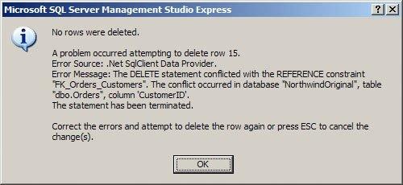

exist in the Orders table (records with the same value in the CustomerID field) unless you
designate a Delete Rule (see the section that follows).

You cannot change the value of a primary key on the one side of a relationship if
corresponding records exist in the related table. For example, you cannot change the value in
the CustomerID field of the Customers table if corresponding orders exist in the Orders table
unless you designate an Update rule in the Foreign Key Relationships dialog for the
relationship (see the section that follows).

If any of the previous three rules is violated and referential integrity is being enforced between the
tables, an appropriate error message is displayed, as shown in Figure 5.13.

Figure 5.13. An appropriate error message appears if referential integrity
is violated.

SQL Server's default behavior is to prohibit the deletion of parent records that have associated child
records and to prohibit the change of a primary key value of a parent record when that parent has
associated child records. You can override these restrictions by using the INSERT and UPDATE
specification, covered in the next section.

For now, let's see how you can establish referential integrity between the tables in your database.
The process is as follows:

1. From the Foreign Key Relationships dialog, select the relationship for which you want to
establish referential integrity.

2. Set the Enforce Foreign Key Constraint property to Yes. This step alone is all you need to
establish referential integrity.

3. If you want to check existing data when you save your changes to ensure that they do not
violate the referential integrity rules, set the Check Existing Data on Creation or Re-enabling
option to Yes.

4. If you are utilizing replication, and want to enforce referential integrity during the
synchronization process, set the Enforce for Replication property to Yes.

Designating Insert and Update Specifications

SQL Server enables you to define rules that dictate what will happen when the user deletes or
updates a record. You can find these rules under the INSERT and UPDATE Specification node of the
Foreign Key Relationships window. The text that follows explores this node, and why and how you
should use it.

The Delete Rule

By setting the Delete rule, you determine what happens when the user deletes a record on the one
side of a one-to-many relationship. For example, by setting the Delete rule to Cascade you
establish the rule so that the user can delete a record on the one side of a one-to-many
relationship, even if related records exist in the table on the many side of the relationship. The user
can delete a customer even if the customer has existing orders, for example. Referential integrity is
maintained between the tables because SQL Server automatically deletes all related records in the
child table.

If you attempt to delete a record from the table on the one side of a one-to-many relationship and
no related records exist in the table on the many side of the relationship, you are able to delete the
record. On the other hand, if you attempt to delete a record from the table on the one side of a
one-to-many relationship and related records exist in the child table, you will delete the record
from the parent table as well as any related records in the child table.

Did you Know?: Tip

Setting the Delete rule to Cascade is not always appropriate. It is an excellent feature,
but you should use it prudently. Although it is usually appropriate to cascade delete from
an Orders table to an Order Details table, for example, it generally is not appropriate to
cascade delete from a Customers table to an Orders table. This is because you generally
do not want all your order history deleted from the Orders table if for some reason you
want to delete a customer. Deleting the order history causes important information, such
as your profit and loss history, to change. It therefore is appropriate to prohibit this type
of deletion and handle the customer in some other way, such as marking him as inactive
or archiving his data. On the other hand, if you delete an order because it was canceled,
you probably want the corresponding order detail information to be removed as well. In
this case, the Cascade option is appropriate. You need to make the appropriate decision
in each situation, based on business needs. The important thing is to carefully consider
the implications of each option before making your decision.

The Update Rule

With the Update rule set to Cascade, the user can change the primary key value of the record on
the one side of the relationship. When the user makes an attempt to modify the field joining the
two tables on the one side of the relationship, the change is cascaded down to the foreign key field
on the many side of the relationship. This is useful if the primary key field is modifiable. For
example, a purchase number on a purchase order master record may be updateable. If the user
modifies the purchase order number of the parent record, you would want to cascade the change to
the associated detail records in the purchase order detail table.

By the Way: Note

There is no need to select the Cascade option when the related field on the one side of the
relationship is an identity field. An identity field can never be modified. The Cascade
option has no effect on identity fields.

By the Way: Note

Other options for the Delete and Update rules include No Action, Set Null, and Set
Default. No Action, the default value, does nothing, and therefore does not allow the
deletion of parent records that have children or the modification of the key field(s) of
parent records that have children. Set Null sets the value of the foreign key field to Null.
Finally, Set Default sets the value of the foreign key field to its default value.

